EXPERIMENT 6
WORKFLOW AUTOMATION USING ZOHO CREATOR
Gym Membership Enrollment & Front Desk Management

Parikshith P
Reg. No: 2116241401062
Computer Science and Business Systems
Rajalakshmi Engineering College, Chennai

Aim
To create and configure automated workflows in Zoho Creator for the Gym Membership Enrollment and Front Desk Management application using Deluge scripting. The workflows validate membership details, restrict registrations based on age requirements, display membership confirmation messages, and perform conditional checks during form submission.

Software Requirements
- Zoho Creator
- Web browser (Google Chrome)
- Gym Membership Enrollment and Front Desk Management application
- Deluge scripting editor

Description
Zoho Creator is a low-code application development platform that allows users to create business applications using forms, reports, dashboards, and workflows. Workflows automate actions based on events such as record creation, record modification, or form submission.
In this experiment, workflows are configured for the Membership_Enrollment_Form in the Gym Membership Enrollment and Front Desk Management application. The workflows use Deluge, Zoho Creator's scripting language, to execute conditional statements, display alerts, and prevent invalid form submissions.
The application includes fields such as Member Name, Age, Membership Type, Email, Phone, Residential Address, and other membership-related details. Workflow automation improves the reliability of the application by checking user inputs and providing appropriate messages.

Procedure

1. Opening the Workflow Section
The Gym Membership Enrollment and Front Desk Management application was opened in Zoho Creator. The Workflow section was selected from the application builder. The Form Workflows tab provides options to create workflows that execute when records are created, edited, or deleted.
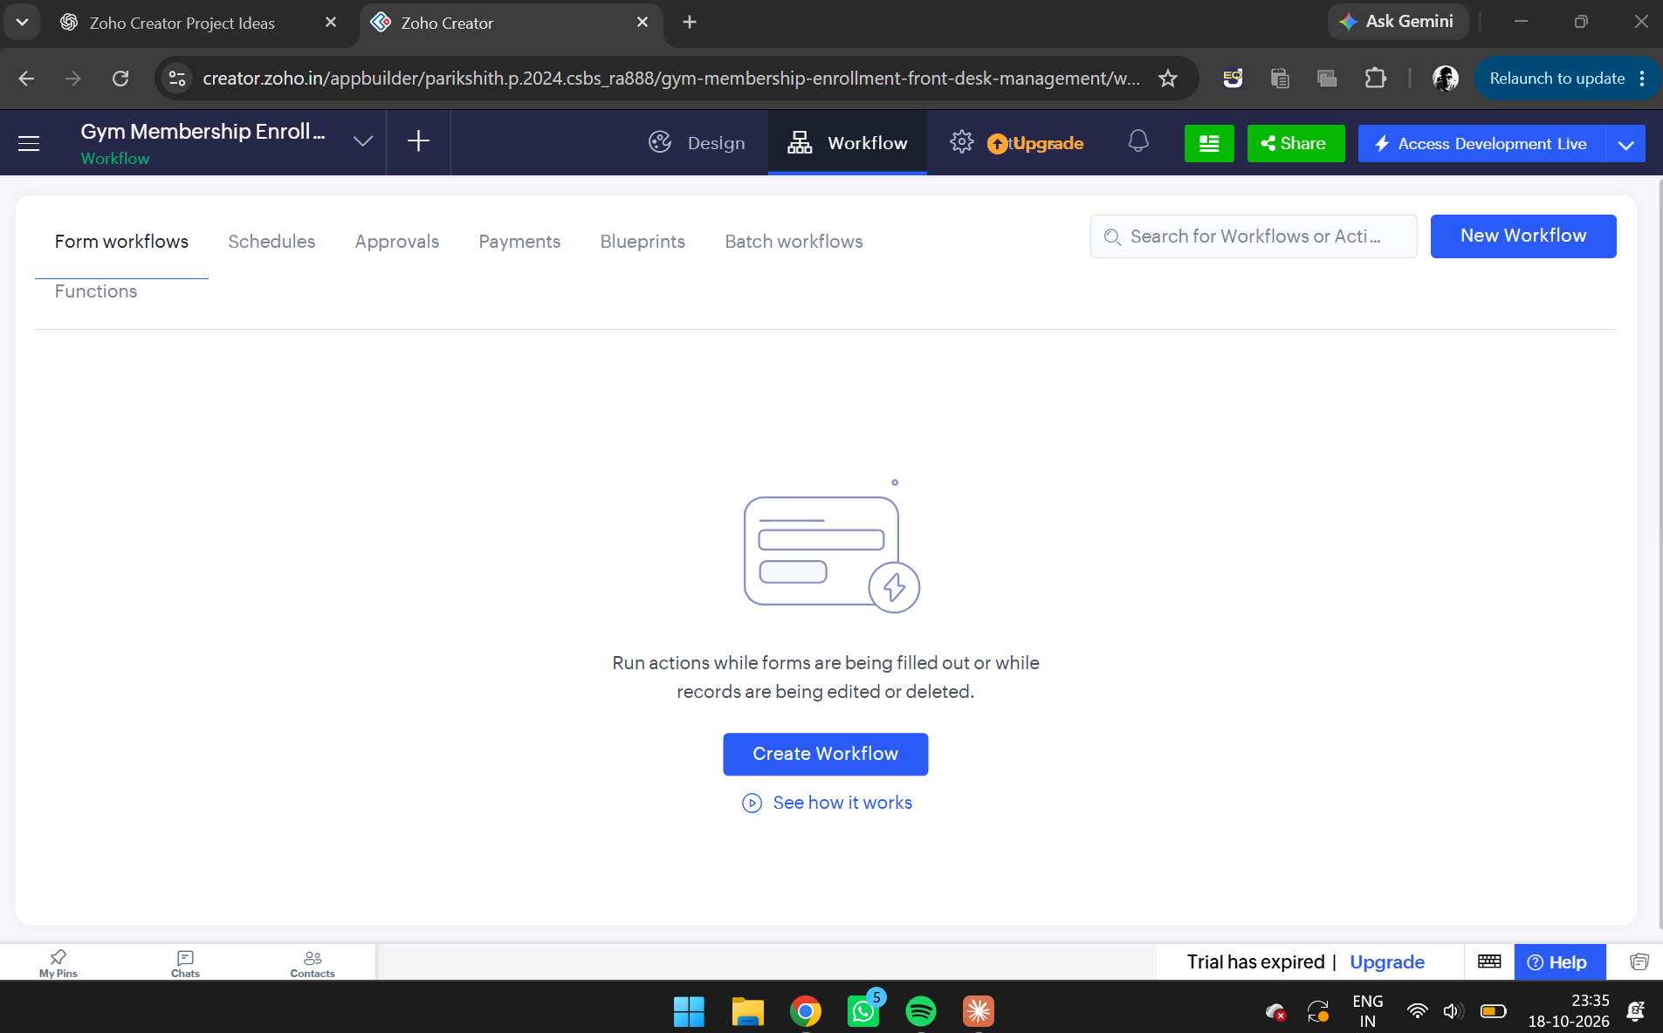
Figure 1. Zoho Creator Workflow section showing the New Workflow option.

2. Creating a Membership Enrollment Workflow
The New Workflow option was selected, and Membership_Enrollment_Form was chosen as the form. The record event was configured to run when a record was created or edited. The form event was set to Validations on form submission.
The workflow was named Membership_Renewal_Reminder. A Deluge script was added to display different messages depending on whether the member selected Renewal or another membership type.
Deluge Script:
if(input.Membership_Type == "Renewal")
{
alert "Membership renewal request recorded successfully!";
}
else
{
alert "Membership enrollment recorded successfully!";
}

The script checks the selected membership type using an if-else conditional statement. If the membership type is Renewal, a renewal confirmation message is displayed. Otherwise, a general enrollment confirmation message is displayed.
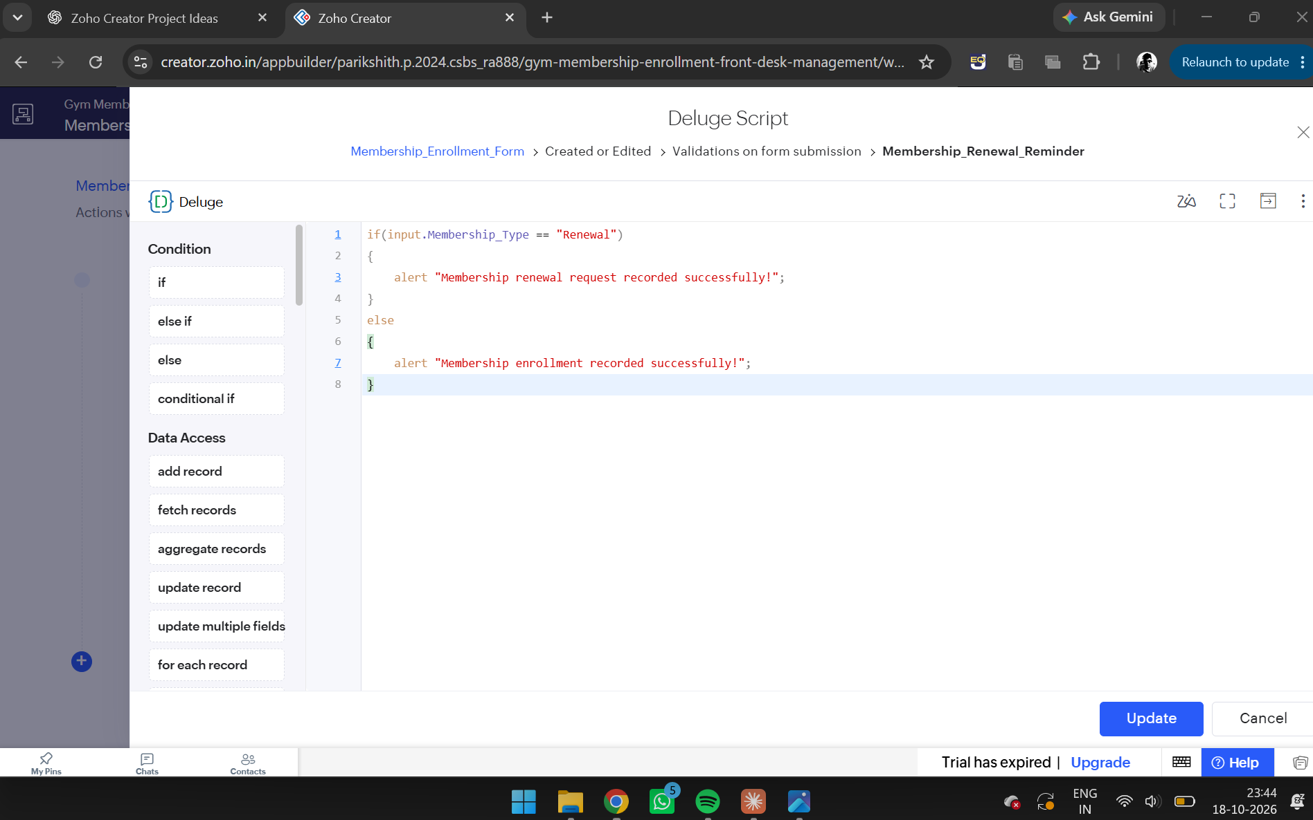
Figure 2. Membership_Renewal_Reminder workflow with the Deluge script visible.

3. Implementing Age Validation
An additional workflow named Member_Enrollment_Confirmation was configured for the membership enrollment form. Its purpose was to prevent members below the minimum permitted age from submitting the form.
The workflow was configured to execute during validations on form submission. A Deluge script was entered to check the Age field.
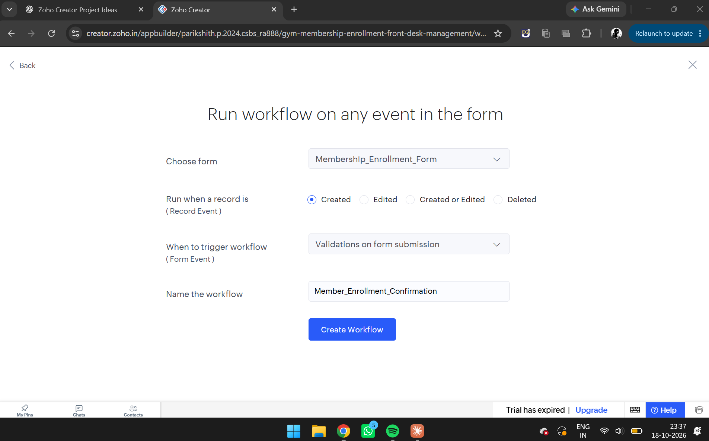
Figure 3. Creating the Member_Enrollment_Confirmation workflow — form, record event, and form event configuration.
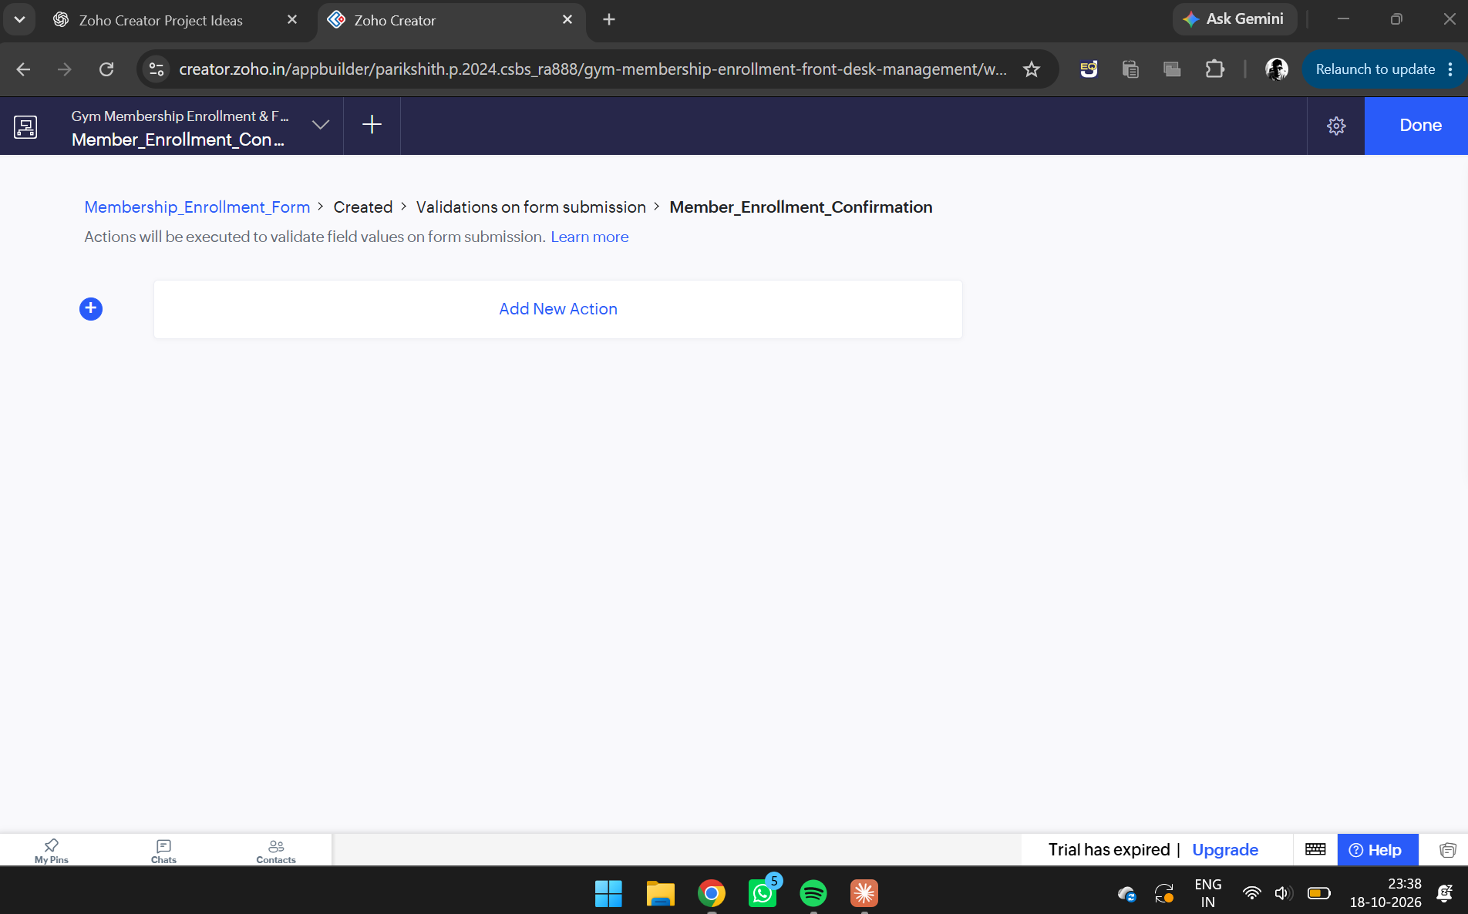
Figure 4. Member_Enrollment_Confirmation workflow ready for a new action to be added.
Deluge Script:
if(input.Age < 18)
{
alert "Member must be at least 18 years old.";
cancel submit;
}

The script checks whether the entered age is less than 18. If the condition is true, an alert message is displayed and the form submission is cancelled. This prevents the record from being submitted with an age below the specified minimum.
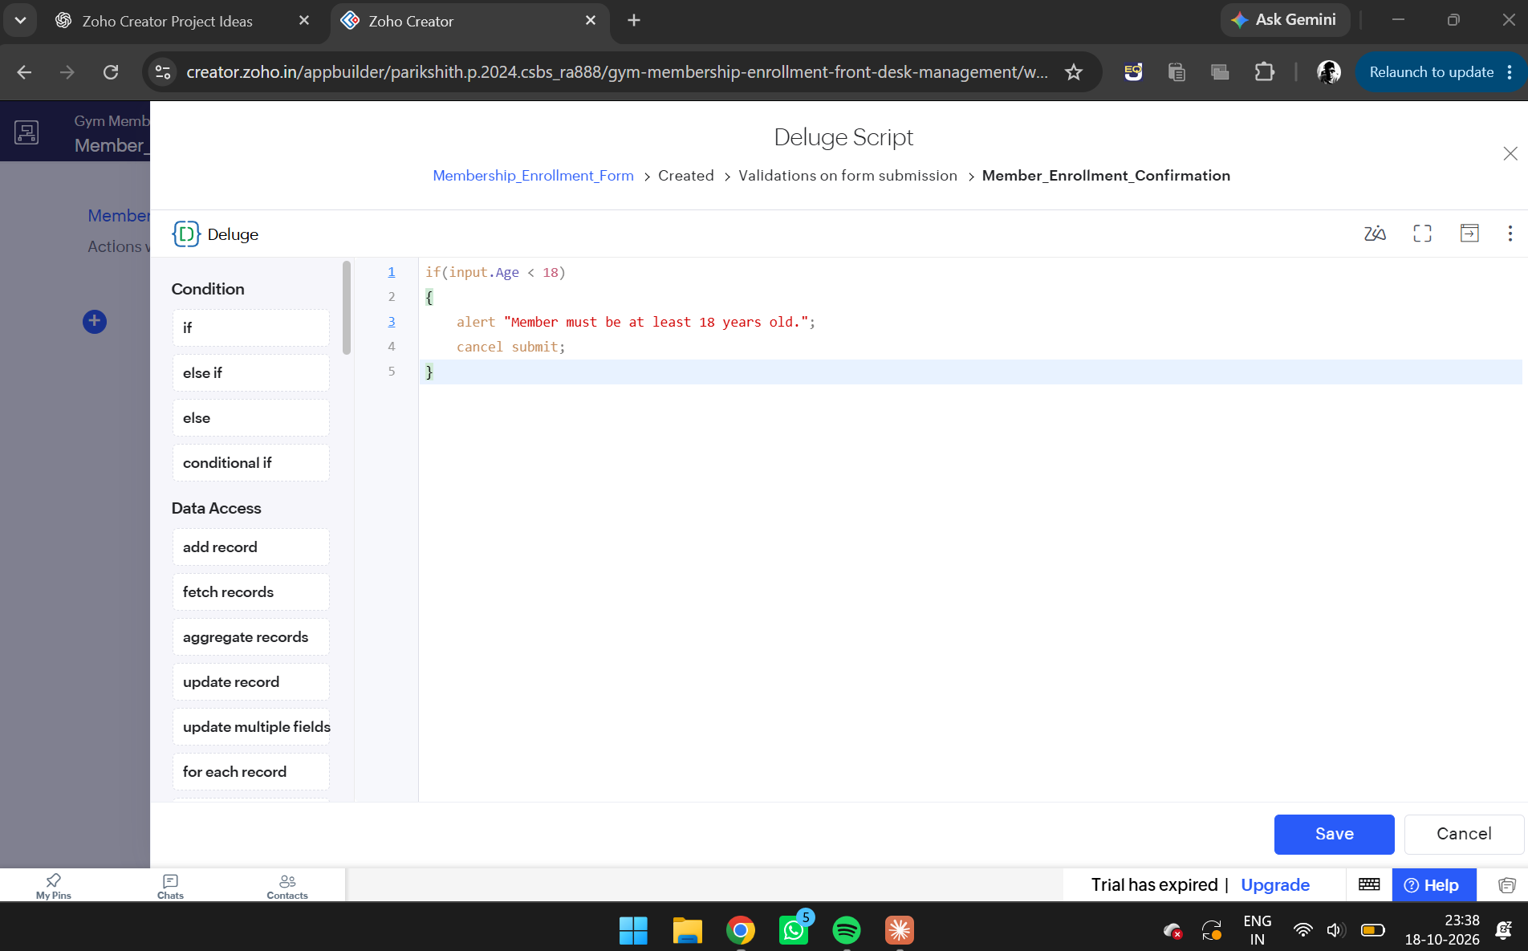
Figure 5. Deluge editor displaying the age-validation script.
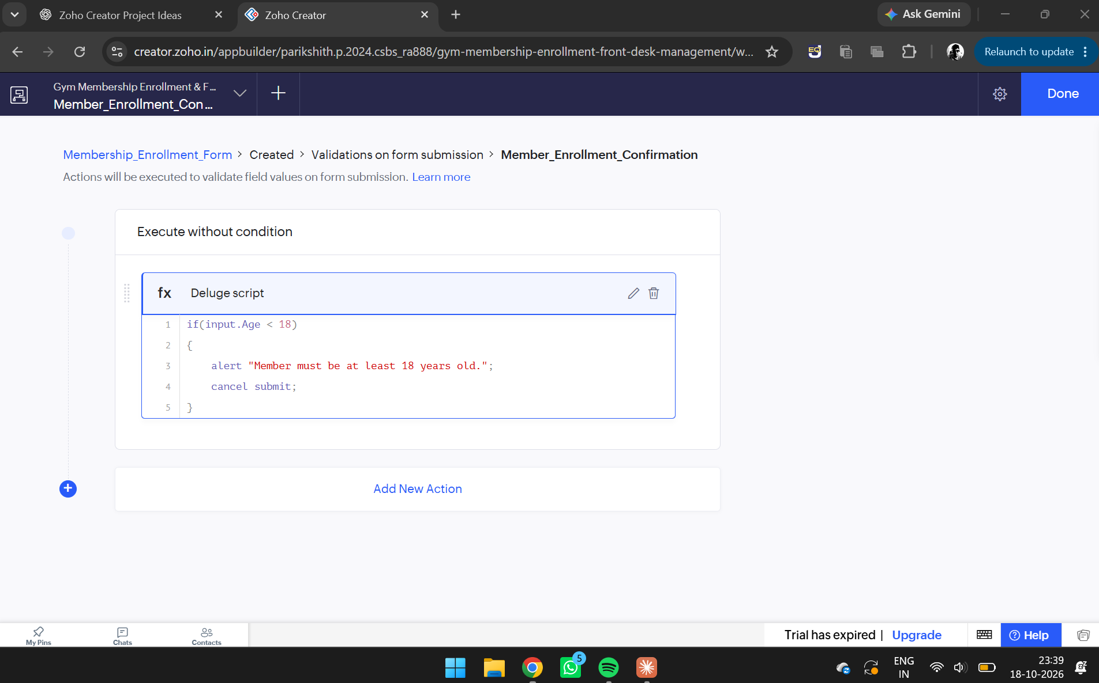
Figure 6. Member_Enrollment_Confirmation workflow showing the saved age-validation Deluge script action.

4. Testing the Age Validation Workflow
The age-validation workflow was tested by entering an age below 18. When the form was submitted, Zoho Creator displayed the message:
"Member must be at least 18 years old."
The cancel submit statement prevented the form from being submitted. This confirmed that the age-validation condition was working as intended during the test.
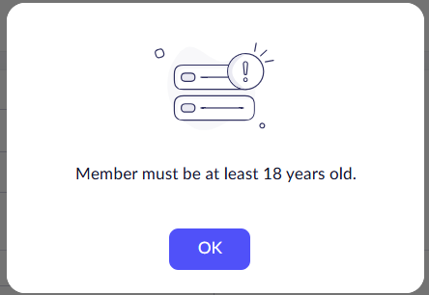
Figure 7. Alert popup displaying the minimum age requirement.

5. Implementing Corporate Email Validation
A workflow named Corporate_Email_Validation was configured to validate the email field when Corporate Enrollment Choice was selected. The purpose was to ensure that a corporate membership submission included an email address.
The email field's actual link name in the application was Email_Address1. This link name was used in the Deluge script.
Deluge Script:
if(input.Membership_Type == "Corporate Enrollment Choice" && input.Email_Address1 == "")
{
alert "Email is required for corporate enrollment.";
cancel submit;
}

The script combines two conditions using the logical AND operator. It checks whether the selected membership type is Corporate Enrollment Choice and whether the email field is empty. If both conditions are true, an alert is displayed and form submission is cancelled.

6. Configuring Membership Plan Confirmation
A workflow named Membership_Plan_Confirmation was configured to display a confirmation message based on the selected membership plan. Conditional statements were used to identify the selected plan and display an appropriate message.
The script was designed for three membership plan values: Quarterly Plan, Monthly Plan, and Annual Plan.
Deluge Script:
if(input.Membership_Plan == "Quarterly Plan")
{
alert "Thank you for choosing our Quarterly Plan!";
}
else if(input.Membership_Plan == "Monthly Plan")
{
alert "Thank you for choosing our Monthly Plan!";
}
else if(input.Membership_Plan == "Annual Plan")
{
alert "Thank you for choosing our Annual Plan!";
}

The if statement checks the quarterly plan, while the else if statements check the monthly and annual plans. When a condition matches the selected plan, its corresponding message is displayed.

7. Saving and Configuring the Workflows
After entering the scripts, the Save or Update option was used to save the Deluge actions. The Done option was selected to finish editing the workflow configuration.
The workflows were organized under the Workflow section of the Zoho Creator application. The configured actions demonstrate how form events and conditional statements can be used to validate information and provide feedback to users.

Working Principle
The workflow automation follows a simple sequence:
- A member enters the required details in the membership enrollment form.
- The form submission triggers the configured workflow.
- Deluge evaluates the specified conditions.
- If a validation condition fails, an alert is displayed and submission is cancelled.
- If a confirmation condition matches, the corresponding message is displayed.
- The workflow provides feedback based on the entered membership information.

This approach reduces the need for manual checking and improves the consistency of the enrollment process.

Advantages
- Automates membership-related checks.
- Prevents form submissions that violate the configured age requirement.
- Ensures that corporate enrollment includes an email address when the relevant condition is met.
- Displays messages based on membership type and plan selection.
- Reduces manual verification by front-desk staff.
- Improves the usability and reliability of the application.

Result
The workflow automation experiment was configured successfully in Zoho Creator. Deluge scripts were used to implement age validation, corporate email validation, membership-type confirmation, and membership-plan confirmation. The age-validation workflow was tested and successfully displayed an alert while cancelling an invalid submission. The other workflows were configured to provide conditional checks and confirmation messages during form submission.
The experiment demonstrates the use of Zoho Creator workflows and Deluge scripting to automate membership enrollment operations and improve front-desk management.

